**Team**

Samir Haddadi

Lasya Dakappa  
Isaac Gariba  
Montez Holmes  
Nesta Parchment  
  
  
Scrum - Artifacts Workbook

**Definition of Done**

| Definition | The objective should be that all incremented releases should be completed alongside testing. |
| --- | --- |
| Purpose | To get a task at a completed state |

**Product Backlog**

| Definition | A prioritized and documented list of wants and needs based on the customer. This is referred to as (PBI) Product Backlog Item |
| --- | --- |
| Purpose | By filtering out prioritized outside requests based on the direction based on the  risk, business value, dependencies, date needed, etc. |
| Ordering | Prioritized by highest importance of value |
| Product Backlog Grooming | A documented list of re-evaluated and re-ordered requests added or removed from a Product Backlog |
| Large Items | Large items or PBI’s are referred to as *EPICS.* Epics are broken down into small chunks before considered as doable work |
| PBIs | Product Backlog Items |

**Sprint Backlog**

| Definition | Extracted from the Product Backlog that contains a list of tasks for immediate execution chosen by the development team, from the highest priority value. |
| --- | --- |
| Purpose | To evaluate / prioritize and track tasks by providing a given time estimate and a detailed image of the Product Backlog Item |
| Source of items | Retrieved from the Product Backlog |
| How are items chosen? | Chosen based on order of importance. Once chosen additional tasks cannot be added to the Sprint Backlog until the current list is completed. |
| What does value  orientation vs. results orientation mean? |  |
| Task Board | A visual representation of Product Backlog, and the many stages represented the assigned Sprint Task, from To-Do, In-Progress and Done. |
| Sprint Backlog Item | Ordered list of requirements |

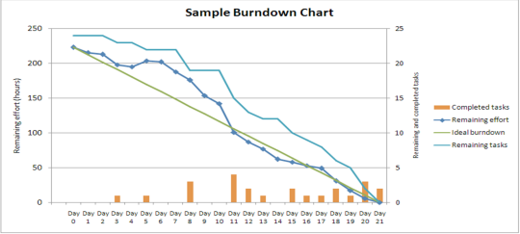**Burndown Chart**

| Purpose | * Displays remaining workload from Sprint Backlog * Simplified progress view of Sprint (Daily) * Assessed Daily * Displayed in work area |
| --- | --- |
| How is it updated? | Deducts the tasks marked done from the remaining task, therefore the graph will decline until there is no task left.  Updated daily by notifying the Scrum Master of our current location within the given task related to the current Sprint Backlog in progress |
| How often is  it used? | It’s accessed daily |
| Significance? | * To showcase the Sprint Backlog remaining work * Simplified progressive view of a Sprint Backlog |

**User Stories**

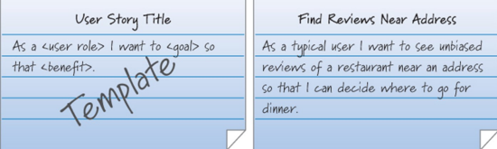

| Definition | A descriptive function based as a statement of what the User **should** and **can** do. Solely established from their viewpoint.   Ex: As a <user> I want to <goal> so that <benefit>  Ex: As a user I want to see the grocery item prices in my shopping cart so I know what I’m paying for individually, |
| --- | --- |
| Purpose | A script for the developer to understand and define part of the product based on a customer's requirements, needs, wants, and feedback.  All task are generated from the Product Backlog |
| Format | Story based, which includes a..  - name  - short informative narrative  - acceptance criteria  - any defined condition  "As a <user type>, I want to <do some action> so that <desired result>.” |
| Source | Product Backlog. It exist from the Product Owner(s), Business Analyst, and users involvement |
| Attributes for completeness | Definition of done |

**Estimation**

| Story Points | Used for estimation activity and efforts by measuring the time of completion based on the size of the item |
| --- | --- |
| Planning Poker | * Each development team member is issued one set of cards. * If when hands are shown, there is not a clear agreement on the amount of work involved, high and low bidders will explain why they chose that bid. * The team will re-vote until they reach a consensus. |
| Fibonacci  Sequence | “A sequence of numbers where each number is the sum of the two preceding numbers” created by Leonardo Fibonacci.  ​​”The Fibonacci numbers were first described in [Indian mathematics](https://en.wikipedia.org/wiki/Indian_mathematics) as early as 200 BC in work by [Pingala](https://en.wikipedia.org/wiki/Pingala) on enumerating possible patterns of [Sanskrit](https://en.wikipedia.org/wiki/Sanskrit) poetry formed from syllables of two lengths” - Wikipedia |